Financial summary
The FRC is a statutory body under the Family Responsibilities Act 2008 and for the purposes of the:
- Financial Accountability Act 2009
- Financial and Performance Management Standard 2019
- Statutory Bodies Financial Arrangements Act 1982.
This summary provides an overview of the FRC’s financial performance for 2019-20 and a comparison to 2018-19. A comprehensive set of 2019-20 financial statements covering all aspects of the Commission’s activities commences on page 61.

Our performance
The operating result for 2019-20 was a surplus of $1.464M. This included an amount of $900K received from the Australian Government upon execution of a MOU with the Queensland Government. The funds received related to the period 1 January 2019 to 30 June 2019.
Table 1: Summary of financial performance.
Summary statement | 30 Jun 2020 | 30 Jun 2019
 | $000 | $000
Income | 4,991 | 3,334
Less: expenses | 3,527 | 3,517
Operating surplus/(deficit) | 1,464 | (183)

Income
The decrease in State Government funding is due to reduced funding on the expiry of the appointment term of the Deputy Commissioner in December 2018 and no new appointment made during this financial year. The increase in Australian Government funding of $900K is in relation to the receipt of a back payment for the period 1 January 2019 to 30 June 2019 received upon execution of the current MOU with the Queensland Government. Other revenue decreased this year and is primarily interest received. The decrease as compared to the prior year is due to a reduction in interest rates resulting in lower interest received and $15K of the prior year’s revenue being due to the recoupment of FY18 expenditure.
Table 2: Summary of income by type.
Income by type | 30 Jun 2020 | 30 Jun 2019
 | $000 | $000
State Government funding | 2,262 | 2,370
Australian Government funding | 2,700 | 900
Other revenue | 29 | 64
Total | 4,991 | 3,334

Expenses
Table 3: Summary of expenses by type.
Expenses by type | 30 Jun 2020 | 30 Jun 2019
 | $000 | $000
Employee expenses | 2,454 | 2,586
Supplies and services | 1,011 | 877
Depreciation and amortisation | 17 | 14
Finance/borrowing costs | 2 | -
Other expenses | 43 | 40
Total | 3,527 | 3,517
Employee expenses decreased due to cancellations in scheduled conferencing in some communities due to COVID-19, staff vacancies carried and the Deputy Commissioner role being vacant for the full year.
The increase in supplies and services is due primarily to the engagement on a contract basis of the former Commissioner for a period of 5 weeks to undertake training and handover to the new Commissioner as well as the engagement of a consultant to assist with various operational reviews and governance projects. These costs were offset by a reduction in travel costs due to COVID-19.
The core functions of the FRC can be summarised into three broad categories:
- Corporate governance: including corporate governance, finance, statistical reporting, training and other administrative functions to ensure the effective and efficient operations of the Commission.
- Community operations: including the operational costs in each of the five communities to conduct conferences, prepare and monitor case plans for clients for attendance at community support services and prepare and monitor income management orders.
- Conference facilitation: including to facilitate the holding of conferences in the five communities, provide support to the Local Commissioners and Local Registry Coordinators to hold conferences, assist with the on-going monitoring of case plans for clients through the provision of data and other information and process income management orders where considered necessary.
The allocation of the FRC’s costs in 2019-20 based on the above core functions was:
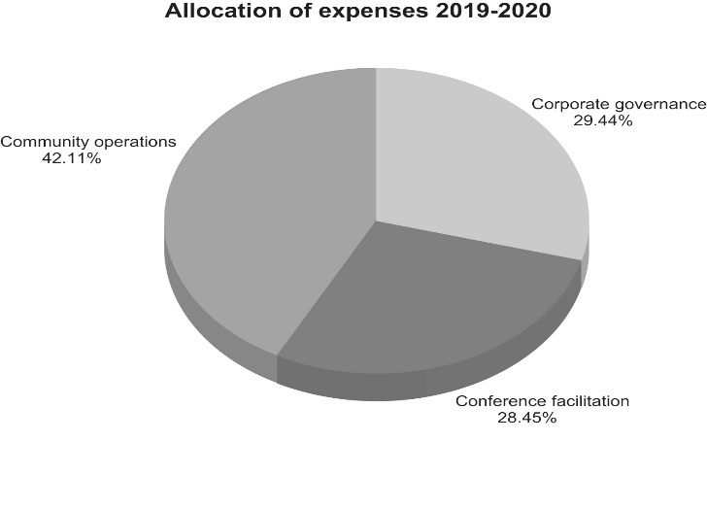
Graph 1: Allocation of expenses
1 July 2019 to 30 June 2020.
The functions of corporate governance and conference facilitation are conducted primarily in the registry office in Cairns with frequent visits to community by staff. Community operations are conducted by Local Registry Coordinators and twenty-nine Local Commissioners, resident in their respective communities. The Local Commissioners are paid as sessional sitting Commission members for conferencing, serving notices, meetings and professional development.
The largest allocation of FRC expenses is in relation to community operations conducted in our five communities broken down as follows:
Table 4: Summary of expense by community.
Community operations expenses by community | 30 Jun 2020
 | $000
Aurukun | 513
Coen | 98
Doomadgee | 541
Hope Vale | 224
Mossman Gorge | 108
Total | 1,484

Our position
Total assets at 30 June 2020 consisted of current assets of cash, prepayments and receivables in addition to non-current plant and equipment and right-of-use assets.
Total liabilities as at 30 June 2020 consisted of payables, accrued employee benefits and lease liabilities.
Table 5: Statement of financial position.
Statement of financial position | 30 Jun 2020 | 30 Jun 2019
 | $000 | $000
Total assets | 3,205 | 1,763
Total liabilities | 312 | 334
Net assets | 2,893 | 1,429
Total equity | 2,893 | 1,429

